Tuesday, November 27, 2018

CHAPTER 5

P.P.5.1 The equivalent circuit is shown below:

-
v_{d}
+

+
v₀
-

+
v₁
-

-
+

v_{s}

+

Av_{d}
-

2 MΩ

40 kΩ

20 kΩ

5 kΩ

50 Ω

i₀

2

1

At node 1, v₁ = (1)

At node 2,

But v_{d} = v₁ - v_{S}.

[2 x 10⁵ (v₁ - v_{S}) - v₀] 4000/(5) + v₁ - v₀ = 2v₀

1600 x 10⁵ (v_{S} - v₁) + 803v₀ 0 (2)

Substituting v₁ in (1) into (2) gives

1.5914523 x 10⁸ v_{S} - 17737556v₀ = 0

9.00041

If v_{S} = 1 V, v₀ = 9.00041 V, v₁ = 1.0000455

v_{d} = v_{S} - v₁ = - 4.545 x 10⁻⁵
Av_{d} = - 9.0909, i₀ = 657 μA

P.P.5.2
-
+
-
+

V_{S}

i

V₁

V₂
+
V₀
-

20 kΩ

10 kΩ

At node 1,

But v₁ = v₂ = 0,

–2

i₀ =

When v_{s} = 2V, v₀ = -4, i₀ = = 200 μA

P.P.5.3 v₀ = –3.15 V

i = 11.25 μA

P.P.5.4 (a) i_{S} =

-
+

i_{S}

V₁

V₂
+
V₀
-

R₁

20 kΩ

R₃

R₂

0 V

(b) At node 2, i_{S} = v₁ = -i_{S}R₁ (1)

At node 1,

-v₁

v₀ = –i_{S}R₁R₃

P.P.5.5 By voltage division

where v₁ is the voltage at the top end of the 8kΩ resistor. Using the formula for noninverting amplifier,

v₀ = 7 V

P.P.5.6 This is a summer.

= –3.8 V

–1.425 mA

P.P.5.7 If the gain is 7.5, then

R₂ = 7.5R₁

But R₄ = 7.5R₃

If we select R₁ = R₃ = 20 kΩ, then R₂ = R₄ = 150 kΩ.

P.P.5.8 v₀ = (v₂ – v₁)

R₃ = 0, R₄ = ∞, R₂ = 40 kΩ, R₁ = 20 kΩ

v₀ =
i₀ = –800 nA.

P.P.5.9 Due to the voltage follower

v_{a} = 1.2 V

For the noninverting amplifier,

v_{o} = v_{o} = (1 + 4) (1.2) = 6 V.

i₀ =

-
+
+
-
-
+

v_{S}
+
v₀
–

200 kΩ

50 kΩ

a

b

But v_{b} = v_{a} = 4

i₀ = 24 µA.

P.P.5.10 As a voltage follower,

v_{a} = v₁ = 7 V

where v_{a} is the voltage at the left end of the 20 kΩ resistor.

As an inverter, v_{b} =

Where v_{b} is the voltage at the right end of the 50 kΩ resistor. As a summer

v₀ =

= [–21 + 31] = 10 V.

P.P.5.11 The schematic is shown below. When it is saved and run, the results are displayed on 1PROBE and VIEWPOINT as shown. By making v_{s} = 1V, we obtain

v₀ = 9.0027 and i₀ = 650.2 µA

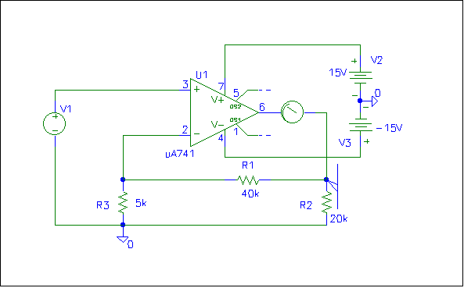
6.502E-04
9.0027

P.P.5.12 -V₀ =

or

(a) If [V₁V₂V₃] = [010], = 0.5 V
(b) If [V₁V₂V₃] = [110], = 1 + 0.5 = 1.5 V
(c) If = 1.25, then V₁ = 1, V₂ = 0, V₃ = 1, i.e.
[V₁V₂V₃] = [101]
(d) = 1.75, then V₁ = 1, V₂ = 1, V₃ = 1, i.e.
[V₁V₂V₃] = [111]

P.P.5.13 A_{v} = 1 + R_{G} =

R_{G} = 354.6 Ω

